CSV API Java Report

By: Ryan Nguyen

Abstract:

This report is a step by step documentation of how I learned to program the plotter, salter, and smoother using JFreeChart. I used various resources to help me along the way. The final results are presented in the google sheets link here: [CSV API Java Report SpreadSheets](https://docs.google.com/spreadsheets/d/1uaSXWFM5dhYqfGEQi_HoVOxVyDtn5mjjtP18Pff3RZA/edit#gid=1429328724)

## Plotter

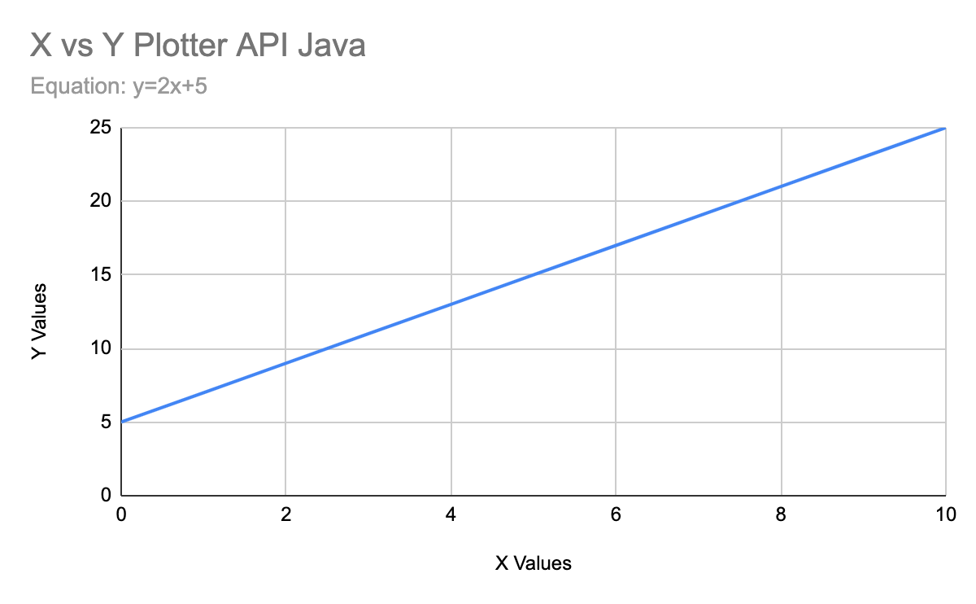

I enjoyed learning about the JFreeChart the most out of this whole project 2. <https://www.codejava.net/java-se/graphics/using-jfreechart-to-draw-xy-line-chart-with-xydataset> Using this website I was able to learn how to draw the chart of the equation y=2x+5 using JFreeChart. The website taught me step by step a default set-up of how JFreeChart works. The website taught in separate methods. First was inserting the data into the createDataset() method, then creating and labeling my chart in the ​​createChartPanel() method, then lastly inputting the constructor. Outputting the csv file is the same way as the original Java programs so that wasn’t too hard, all you had to do was know where to put it.

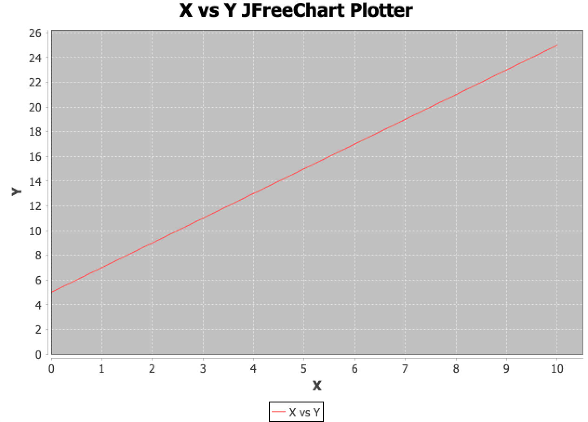

## Salter

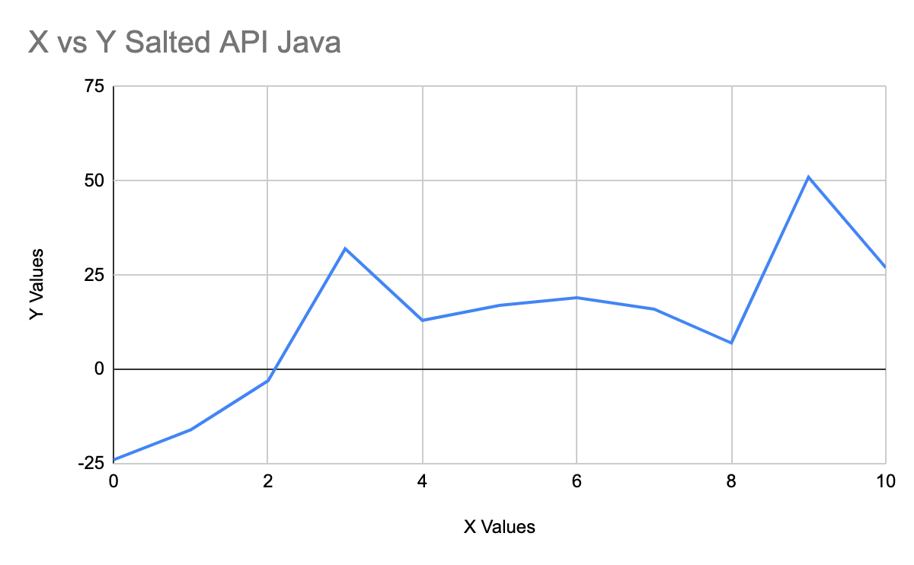

After learning how to graph the data of the equation, salting the data was pretty easy. I knew how to read the csv because of the original Java salter program. The only difficult part about salting was adding the x and y values together with the series1 variable to be added back to the dataset.

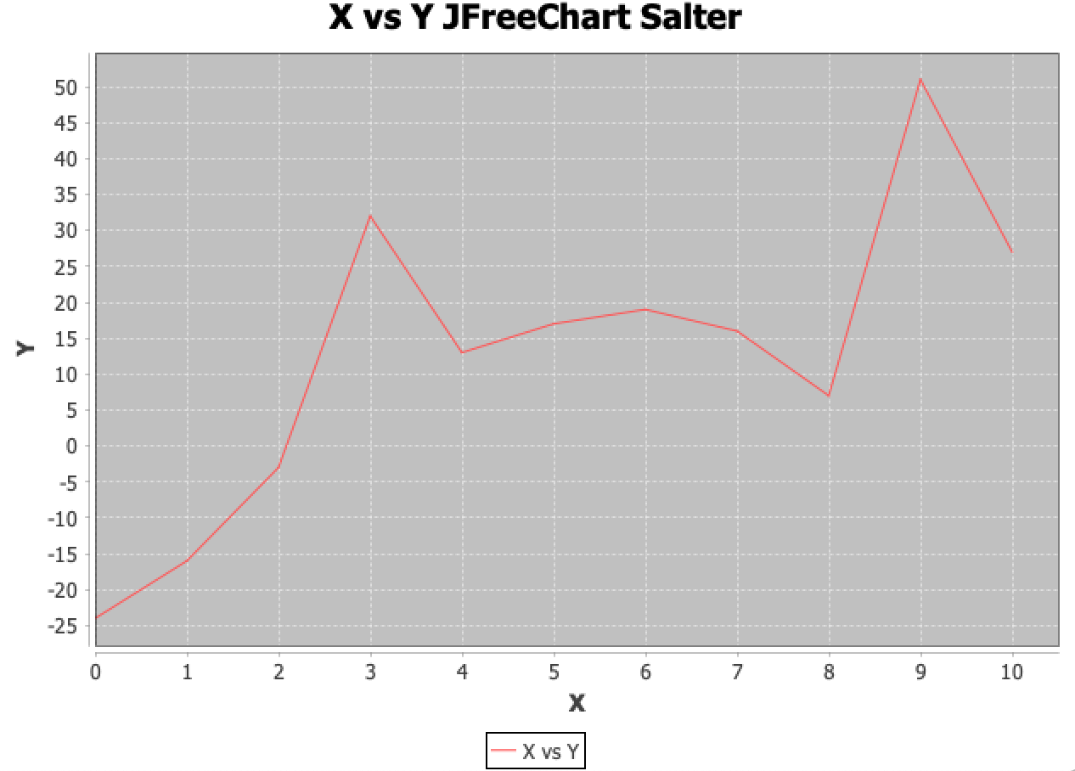

## Smoother

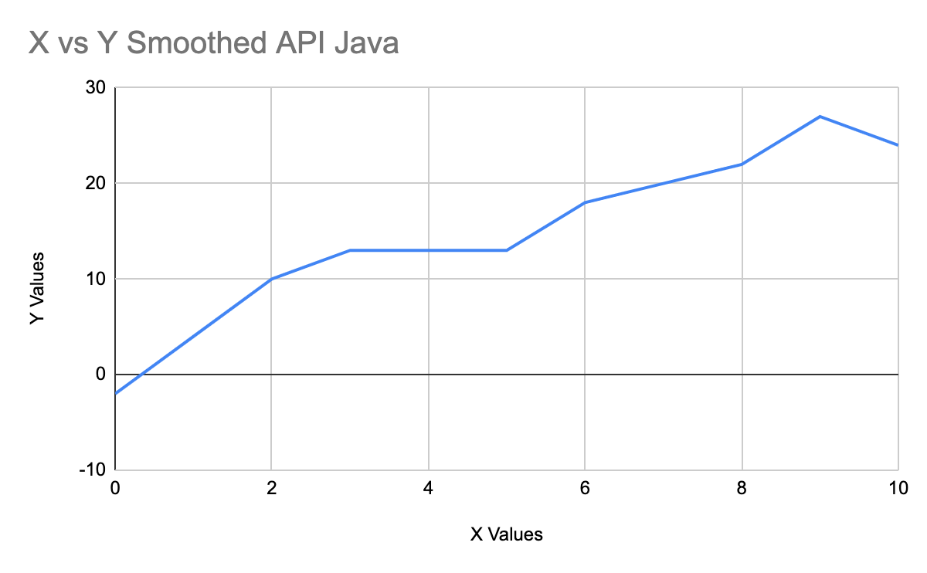

Smoothing was to my surprise easier than the salting process. After learning that I had to make another for loop to input the x and y values to the series and where to add the values, all I had to do was copy and paste my previous work. All 3 programs follow the same structure so it wasn’t too complicated to understand.

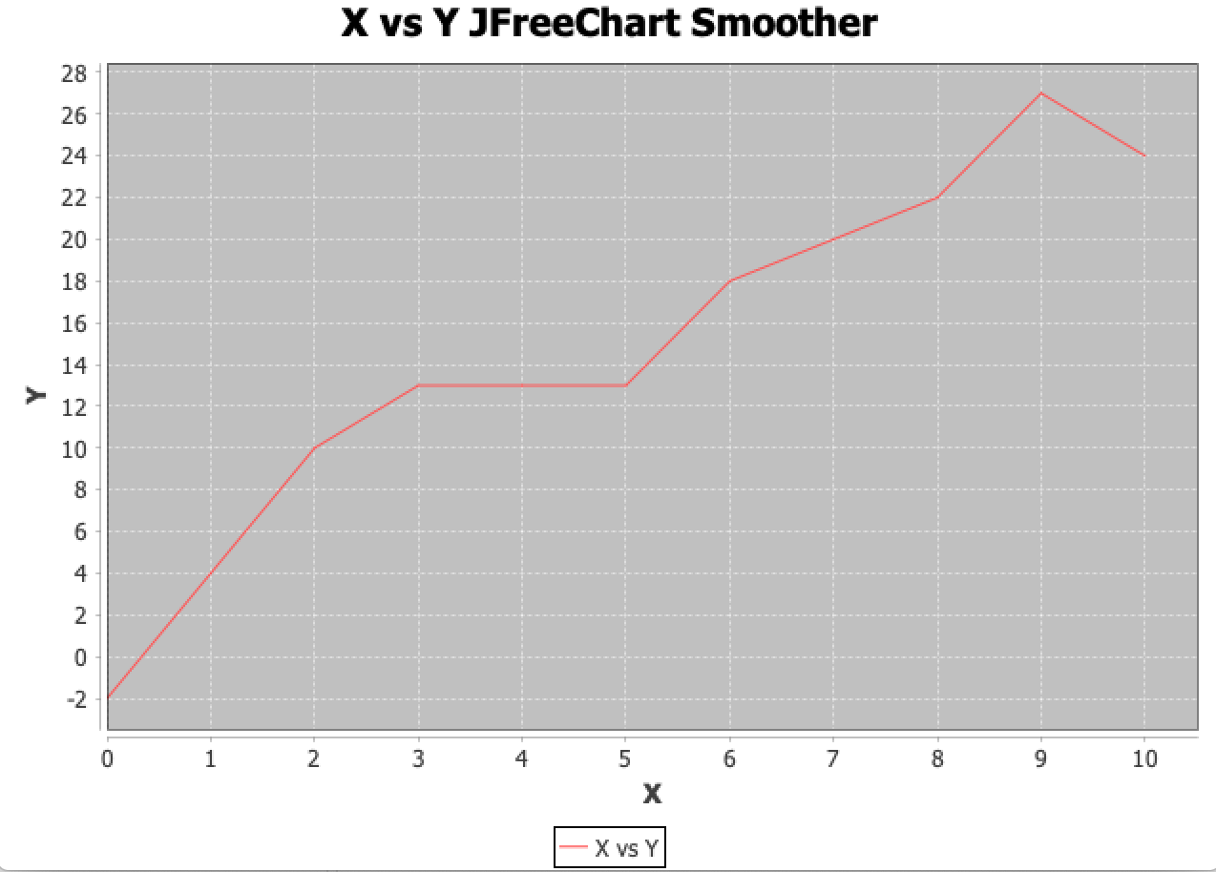

## Combined Graphs

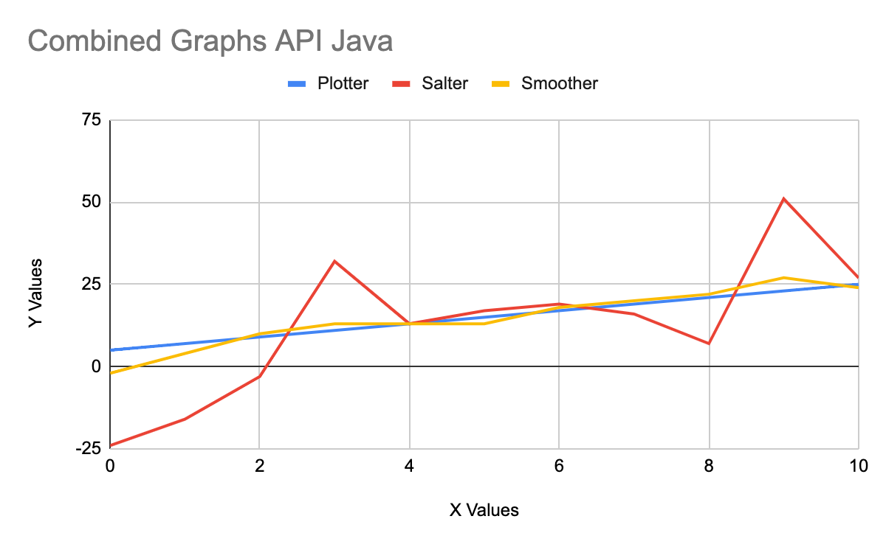

As you can see in the combined graphs, the plotter is as it should be a linear graph depicting y=2x+5. The salter is within a range of -30 to 30 correctly salting the plotter. The smoother is a trend line going through and within the salter smoothing it out.